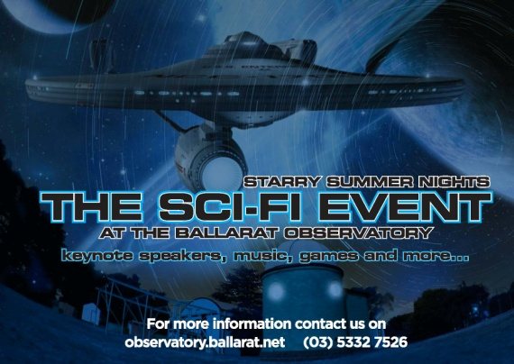
Stall Application
Saturday January 31st, 2015
6pm - 11pm
Ballarat Observatory Grounds
Entrance Stall Holders: Magpie Street
Entrance Public: 439 Cobden Street
Mt Pleasant , Ballarat

Original, Quality, Educational, Games, Sci Fi stalls are welcome. No Food Stalls.

Stall Application Form
All stalls in the Observatory grounds.

Please complete this form and return as soon as possible to: PO Box 284, Ballarat, Victoria, 3353
Or email to: bas@cbl.com.au

Product/Goods Name:
Contact Person Name:
Address:
Phone: Mobile:
Email:
Website/ Blog/ Facebook Page:

Detailed Description of goods: (photos of products would also be beneficial)

Stall Prices:

General Stall | Non- Profit Stall | Powered Site
$20 | $10 | extra fee $50

I ............................................................................. agree with the Starry Summer Nights The Sci Fi Event (SSN Sci Fi)application guidelines.

You keep this page for your records:

Do not send this back with your entry form

Stall Guidelines
Stallholders are responsible for all tables, shade and weather protection.
Stall holders must have Public Liability Insurance and attach copy of current certificate with application.
Stall Holders are responsible for all electrical leads (minimum of 10 metres in length) and these must be tagged correctly.
Stall holders cannot sell products from their car or trailer and the vehicle can be parked in observatory car park. Stall sites will measure 3x3 metres or more if required.
Stall holders can set up from 4.30pm and must be completely set up and ready to sell at 5.45pm.
Stall Holders are to report to Oddie Room and report to a SSN Sci Fi Site Manager upon arrival.
Stall holders cannot pack up before 9.00pm.
The SSN Sci Fi reserves the right to refuse applications if stalls do not adhere to the Stall Guidelines.

Important Information: Do Not Send Payment with this form. If your stall application is accepted - we will send you an email or call you. You will then be required to pay for your site within 14 days of this notification. Applications close
14th january 2015. Administration fee of $15 deducted for cancellation.
* If your application is not accepted, we will contact you accordingly
For further information please call 0429 199 312

Send forms to:

Stalls at Starry Summer Nights
The Sci Fi Event
PO Box 284
Ballarat3353
Or return email to:
bas@cbl.com.au

