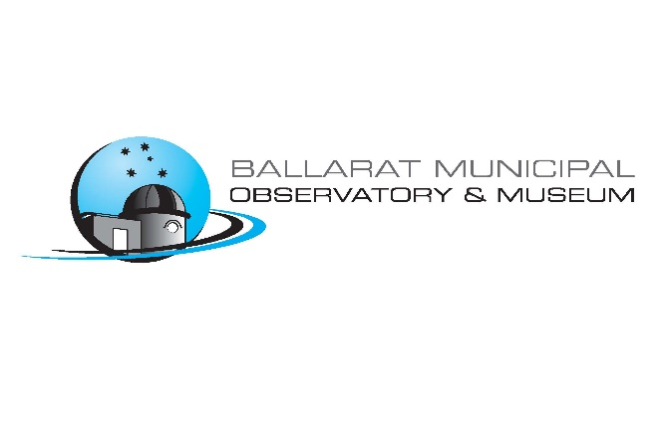
133rd Year
“Discover the Amazing Universe.”

ABN 45 605 034 065
P.O.Box 284
Ballarat 3353
Email: bas@cbl.com.au
Website: http://observatory.ballarat.net
Ph: 03 5332 7526
M: 0429 199 312

Capturing the Moon Exhibition Conditions of Entry
Eligibility
Students under 18years must have the consent of their parents. Entries will be accepted only from Australian residents of the COMMONWEALTH OF AUSTRALIA and its TERRITORIES. The photograph content is not restricted to Australia.
What must be submitted
The entry must be a still work that has been produced by photographic means of the Moon. The accompanying notes about the image should describe the particular scientific content of the image, suitable for display along with the image. Entries must be the original work of the photographer, who must also be the sole copyright holder of the work. They must also ensure that they have obtained the consent of any human included in the image/s. Entries must not have previously been exhibited at a major public institution, selected as finalist of any other prize, or entered in previous competitions
Submitting entries
Entrants must submit a Photographers Submission Form. Each image must be submitted as a digital file saved as a jpeg up to 2MB, the longest edge of the image must be at least 2000px, and upload both files to Dropbox:
https://www.dropbox.com/home/File requests/Capturing the Moon
Original prints (hard copies) of entries will not be accepted for the initial judging and selection process. The organisers will accept submissions until midnight on 31 May 2019. There is a limit of 3 images you may submit as entries.
Fees
The fee for per entry is a non-refundable Free for Primary School and Secondary Students, $15 Adults. Payment can be made by:

Direct Deposit
Acc: Ballaarat Astronomical Society
BSB 063 507
Acc No 1005 6172
Remittance: Your Name and email to bas@cbl.com.au
Or by Cheque or Cash to Ballaarat Aastronomical Society 439 Cobden St Mt Pleasant 3350
Ownership of photograph once it is submitted
Intellectual property rights in entries remain with the finalist as the copyright owner. It is a condition of entry that the entrant grants to the Ballaarat Astronomical Society, without conditions, a perpetual royalty-free licence to use, publicly display, publicise, reproduce the entry or part of an entry, including in electronic form and broadcast, for publicity, promotional, educational and administrative purposes associated with the Capturing the Moon Exhibition, in both digital and print mediums.
Integrity of photograph
All entries must be true images, faithfully reflecting and maintaining the integrity of the subject. Entries made up of composite images taken at different times and/or at different locations and/or with different cameras will not be accepted. Image manipulations that produce works that are more "digital art" than true astronomical images, will be deemed ineligible.
Judging
A panel nominated by the Ballaarat Astronomical Society will select the finalist works for exhibition from the digital images supplied. The judges will select the winner of the acquisitive prize from the exhibited work. The winner will be announced on Sunday 21st July 2019. At all stages, the decision of the judges is final, and no discussion will be entered into.
FINALISTS
Final Selection
Images selected for exhibition will be framed and on continuous display for the duration of the exhibition. The framed images can be available for sale during the exhibition but must stay for the whole of the exhibition, until 9th August (could be extended but a firm date will be available closer to the date). Contact Judith on 0429 199 312 if you would like more information about having your image available for sale. The Ballaarat Astronomical Society reserves the right to remove works from the exhibition at its discretion.
Section Winners
There is an acquisitive first prize of $750 Adult Section, $500 Secondary Section, $300 Primary School section, sponsored by the Ballaarat Astronomical Society. The printed winning framed photographs immediately become the property of the Ballaarat Astronomical Society. All other unsold work can be collected by the copyright owner at the closing of the exhibition from the exhibition venue.
Sponsors
